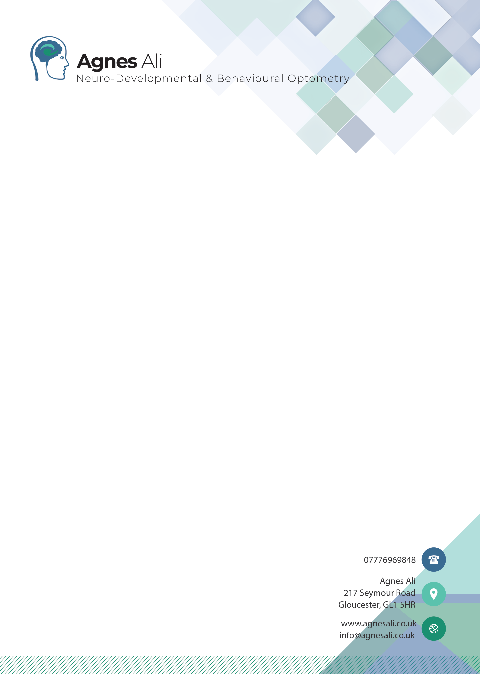

Personal & Confidential Information
To the parents of John
Dear

Re: John D.O.B: 01/01/01
Thank you for bringing John to see me on the 01/01/01. It was a pleasure to have him in practice.
John has been found to have some difficulties at school with concentration, reading and writing. He seems to reverse letters, and his balance and coordination has found to be lacking compared to many of his peers. His father is dyslexic.
John comes across as a very inquisitive boy who wants to know how things work and why. He is, however, struggling to focus on a task for any length of time.

I have made assessments in the following areas:
- Refraction and any eye prescription
- Reading, benefit of coloured overlay
- Eye Teaming – convergence
- Eye Focusing – accommodation
- Eye Movements
- Visual Perception
- Primitive and Postural Reflexes
- Balance and Bilateral Integration skills

Section 1- Refraction and Eye prescription
Overview
Standard visual acuity (VA) is considered to be 6/6. However, anything that is up to 2 lines larger than 6/6 is still considered within the normal range.
 | VA | Prescription | Corrected VA
R | 6/7.6 | +0.25 | 6/7.6 and N5
L | 6/7.6 | +0.25 | 6/7.6 and N5

Finding

John sees well in the distance with each eye. John does not need to wear glasses for better clarity of vision. It was interesting to observe that when reading the letters on the chart, John found it difficult to read them in the right order. He read letters 1, 2 and 3 from the left, then letter 5 and then reversed to letter 4 on the line (there are 5 letters on each line). He did this each time he read a line.

Section 2- Reading
Finding
John read several lines of N8 size print of an age 6-7 reading chart out loud for me. His reading was slow and quite jerky. He missed out several words and made up some of the words using starting letters from what he saw printed.

I tested John for the use of coloured overlays, but he did not observe any improvement in appearance of text with any of the colours.

Section 3 - Eye Teaming
Overview
Convergence is the ability to point both eyes inwards to look at an object, fuse the two images and see it as one single image. The highest levels of fusion allow the person to see with depth perception – known as ‘stereopsis’. Stereopsis is scored from 600 to 20 and a score of 40 or less is reasonable.
Fusional reserves measure the range of convergence and divergence that a person can use, and they are an indication of how well a person can maintain convergence. Normal near point of convergence (npc) is a measurement of less than 8-10cm.

Finding
John showed a good near point of convergence (npc) of less than 6 cm.
Base in (divergent) fusional reserves were found to be normal at distance and near. Base out (convergent) fusional reserves were normal at distance and normal at near.
John was also tested for stereopsis (depth perception) and scored an excellent 20 seconds of Arc.

Section 4- Eye Focusing
Overview
Accommodation is the changing of power of the lens of the eye to enable focusing from a distant object to a near object and back again.
Amplitude of Accommodation gives the range over which accommodation takes place and gives a near point when clear focusing can no longer be achieved. A normal finding for amplitude of accommodation would be equal to or less than 10cm.
Accommodative facility assesses the flexibility of the accommodation system by measuring the ease at which the person can change their accommodation to see N5 print clearly through a flipper containing a -2.00 DS lens followed by a +2.00 DS lens. The accommodative facility measurement is recorded as the number of +2.00/-2.00 cycles that can be cleared in one minute (cpm). Normal measurements are 10-14 cpm.
Finding
John had a normal amplitude of accommodation of 8-10 cm.
For John accommodative facility was measured binocularly, and he found it hard to clear the +2.00DS lenses. He was working at somewhat reduced speed. This may affect his ability to copy from the board, where one must quickly focus the eyes up close and then relax the focus to see the board clearly. John will take a few seconds to do this switch of focus and hence he will be slower with copying than his peers. He may also not retain the information he is asked to copy as well as other children, as his brain has to devote more attention to the focus of his vision, hence not being able to attend as well to the text being copied.

Section 5- Eye Movements
Ocular motility
First, I tested John’s ocular motility looking at the action of the six extraocular muscles of each eye looking for under-action or over-action. All the muscles were able to show full movements.
There are three main types of eye movement that I test:
- fixation – keeping the eyes steady on the target
- pursuit (following) eye movements and
- saccadic (jumping) eye movements.
Saccadic eye movements are used to differentiate words and space in the text, whilst pursuit eye movements give the actual word.
Finding
John had difficulties with fixation, pursuit and saccadic eye movements, and eye movement control. John used head movement in addition to just moving his eyes, to be able to track a moving target.

The DEM (Developmental Eye Movement test)
The DEM test looks at reading speed, using numbers rather than letters and is split into 2 parts.
The first part of the test looked at the automaticity of number calling skills, the speed at which the child can see the number, process in the brain what it is and say it verbally.
The second part looks at a child reading numbers spread across a page and reading them line for line, simulating the visual skill needed to read a page of print.
Finding
Part 1- John scored at the <1st percentile for this part of the test.
Part 2- John from the outset of the tasks said that this was too difficult to do. I was able to convince him to give it a try, but after initially reading the first 2 lines well, John started to get somewhat muddled with the numbers and started missing out complete lines. I was not able to score this part of the test as we did not complete it. But the finding does tie in with poor oculomotor skill that was observed when watching John track a moving object.

Section 6- Visual Perception
The Jordan Left-Right Reversal Test (JLRRT)
John was presented with a page that has approximately 60 upper- and lower-case letters as well as the numbers 1-9 printed on it. About 30% of these letters and numbers are printed in reversed form. He was asked to mark all the letters and numbers that were the wrong way round.
Finding
John only found 4 of the presentations. This puts him into the <1st percentile for his age group.
This finding is not unusual, seeing that John, although being able to know his own right and left side of his body, was unable to associate right and left to other people or objects. If a person does not have an innate feeling of their own right and left side, any directional task becomes difficult as there is no reference point with which to link directionality of a letter.
It was also observed that John did not approach the tests in a very methodical manner. John picked out the letters he saw wrong immediately on the page. He did not start with looking at the first letter in the top left corner and work his way through the page line by line looking at each letter in turn.
This unstructured approach does put him at a high risk of missing out crucial information. Looking at whether John approaches other (school) tasks in a logical, methodical way or whether he shoots in hap-hazardly would be interesting. As if he does this with other tasks, teaching him better strategies may make him better able to deal with them. I am not certain whether John looked at all the letters presented. If he didn’t, he may well have missed more presentations than if he had used a more methodical method.

Rosner Test of Visual Analysis Skills
I further asked John to do the Rosner Test of Visual Analysis skills. This involved him copying several shapes on a dotted grid.
Findings:
John shows some difficulty with visual motor integration. He was unable to accurately keep his copied lines straight and neat. His pen control was poor, and although he is showed some understanding on form and shape, recreating it accurately was difficult for him. He scored at the 5th percentile for his age group for this task.

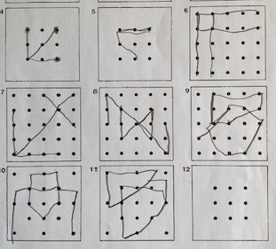
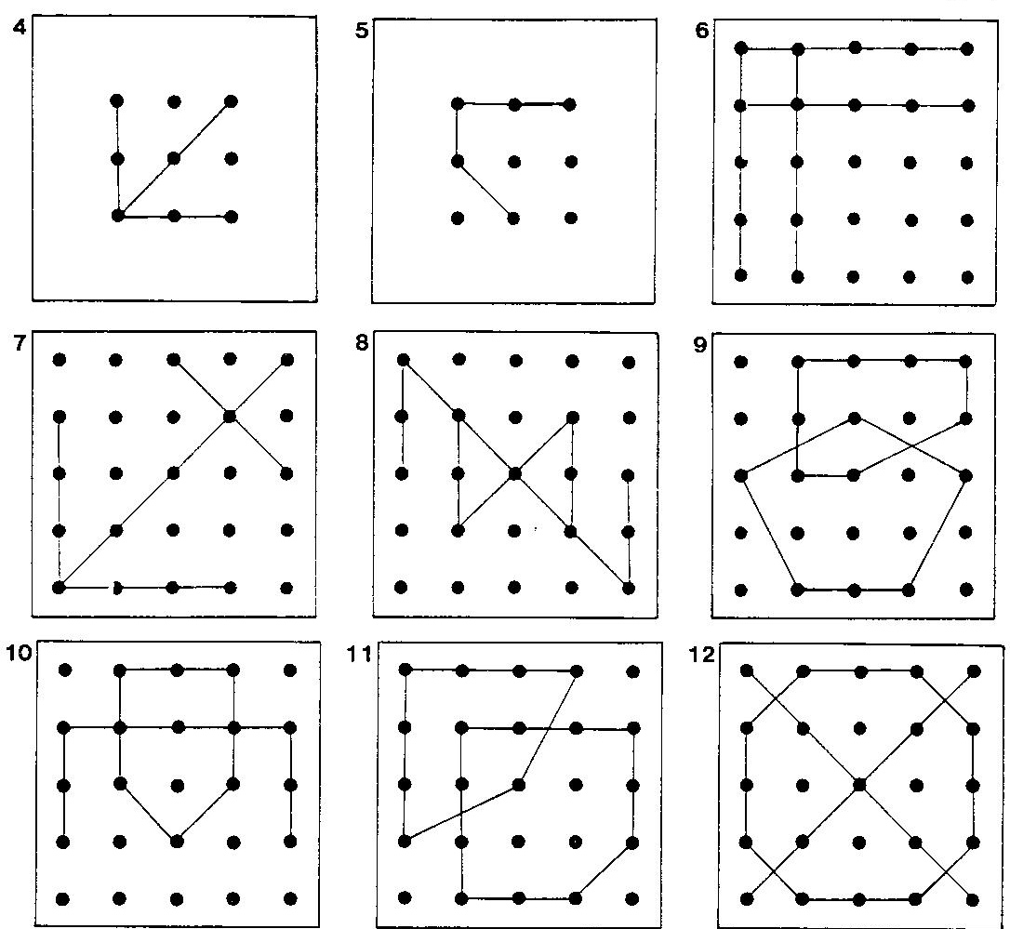

Given the length of the assessment and John’s reduced span of attention I only tested 2 parts of the Test of Visual Perceptual Skills 4th Edition (TVPS).
The results of the individual sub sections are below.
Subtests | Subtest scores
 | Raw Score | Scaled Score | Percentile Rank
1 Visual Discrimination | 10 | 11 | 63rd
2 Visual Memory
3. Spatial Relationships
4 Form Constancy
5. Sequential Memory | 8 | 8 | 25th
6 Visual Figure Ground
7 Visual Closure
Total Scaled Score

Visual discrimination asked John to match a picture with its exact likeness. Some of the differences were minimal and John scored above average for this test. He does have a keen eye for things and details and is able to pick them out and see similarities and difference.
The second part of the test performed looked at remembering a sequence of shapes, a skill that is needed for word recognition and spelling. John scored in the low average range there, meaning he may find it hard to remember what a word looked like. So, he may be able to decode on one line but may not remember easily what it was when he comes across the same word a few lines later. Further getting spellings right has a lot to do with how we see the word form, and if that is not easily remembered it is hard to know whether a spelling “looks” right.

Neurodevelopmental Assessment:
When a child does not develop visual skills normally there are often some underlying neurodevelopmental steps that have been missed out or poorly developed. I therefore looked at several areas of neurodevelopment to identify any weaknesses in the development of the brain that can be contributors to the above found difficulties.

Section 7- Primitive and Postural Reflex assessment
Overview
I testes John for three primitive reflexes:
- Tonic Labyrinth Reflex (TLR)
- Asymmetrical Tonic Neck Reflex (ATNR) and
- Symmetrical Tonic Neck Reflex (STNR).
These primitive reflexes are used by the child as a baby as a base for their motor development. By one year of age the child should have higher controls of their motor system, and the primitive reflex movement response should be replaced by a mature response, using postural reflexes.
The learning of gross and fine motor skill builds on the learning that a baby makes from the primitive reflexes in their first year of life. Fine motor skills such as convergence, accommodation and eye movements are needed for accurate, comfortable reading, handwriting, visual processing and thinking.
The demonstrable presence of the primitive reflexes beyond one year means the child hasn’t developed the complex movement skills as well as would be expected. This will interfere with visual development and can also cause poor coordination and unintended body movements.
Finding
I found both the ATNR and the STNR reflex significantly active.
A retained ATNR reflex has been linked to poor development of: eye movements, visual attention, bilateral integration skills, right and left discrimination, hand eye coordination, handwriting, ability to “get ideas on paper” (child may be good orally but can’t write their thoughts down).
The retained STNR influences body posture. This can be displayed in a tendency to slump when sitting (and using their hand to prop their head up). It is also linked to poor hand eye coordination, slowness in copying from the board and difficulty in learning to swim (especially breaststroke) and loss of attention/concentration due to discomfort in sitting in one position for any length of time.

Section 8- Balance and Bilateral Integration skills
I asked John to carry out several balance and gross motor tasks. He did not find body coordination easy and had to be shown very carefully what was expected of him. After several tries, he was usually able to repeat the required movement, but it took a lot of concentration and effort.

Looking at Bilateral Integration, (the way John uses his left and right brain hemispheres) it became obvious that when being asked to use the two hemispheres together, he started to struggle. He can use the right side of his body separately and the left side but when asked to move his right arm and left leg or vice versa his immediate default was to use either right arm and right leg or left arm and left leg. Only through thinking and correcting himself was he able to do the task. Further, the movement did not happen in unison but was sequenced. Arm first, then followed by leg or vice versa.
Poor communication across the two hemispheres can affect all aspects of life, from difficulty tying shoe laces and eating with a knife and fork, to decoding information and making sense of it, to getting ideas written down on paper, linking known factors to new situations and problem -solving skills as well as emotional regulation and the ability to judge the consequences of actions.
This can be likened to 2 people driving from A to B (pre sat nav). One person is the driver, the other is the map reader and navigator. If the two communicate well and leave each other to do their job well, they will arrive swiftly and in a relaxed manner. However, in poor bilateral integration, the two do not communicate well. The driver does not listen to the map reader, and the map reader interferes with the driver. They will still eventually arrive at point B, but there is a lot more stress on the system and they may well have taken significantly longer to get there (reduced processing speed).

Summary
There are many causes that can result in literacy difficulties, but looking at all the tests performed John does show:
- Significant oculomotor difficulties
- Reduced bilateral integration skills
- Retained ATNR and STNR reflexes
- Poor laterality
- Poor visual motor integration.
All these combined makes learning more difficult as John is using a significant amount of brain processing power to move his eyes to the right place for reading, while suppressing his primitive reflexes that are still active. In short, this means that there is less brain capacity left for learning and remembering. John will take longer to learn things and will need to re-read for good understanding. He will need to work harder than his peers to achieve his potential.

Thankfully all the above findings respond well to a therapeutic approach. I therefore recommend a course in Optometric Vision Therapy (OVT), which will help all these areas. A typical programme will take between 6-12 months to complete. For a programme to be successful, the exercises learned in the monthly therapy sessions will need to be practiced daily. 7 days a week gives the best and fastest results. Performing the exercises 5 times a week still yields good progress. Doing the exercises 3x or less a week usually results in very little progress. With most children I work on 3 exercises at any time. Each one will not take longer than 2-4 minutes. So, a total of 10 minutes dedicated work time a day is needed. This can be split up into 3 sessions of a few minutes each.
First positive developments are often seen within the first 2 months of therapy.
The amount of capacity created through therapy and the way a child uses that “freed up” space differs from case to case. Hence it is hard to accurately predict how much easier a child will find academic learning post therapy. With some children I see dramatic changes and it’s like a blockage has been cleared and the child can soar, and with others, we get improvements in visual comfort, balance, coordination, improved sport skills and often ability to concentrate but they still have to work very hard to reach targets. Given the family history of dyslexia and the extremely slow speed of number readings in the DEM test, I have a feeling that John is likely to fall in the latter category, and it may well be worthwhile that on completion of a course of Vision Therapy, a Dyslexia assessment is arranged.

Recommendations for school:
As John has significant eye tracking difficulties, I suggest he is seated facing the board and teacher square on and not placed sideways in the classroom. This will make copying from the board and interacting with the teacher easier as he will only need to deal with gaze shifts up and down and not sideways.
As he works through vision therapy and develops his eye movement skills, this placement will become less and less important.
I also recommend that if John is being presented with significant amounts of text (more than 3-4 lines), that the text is nicely spaced out with good gaps between the paragraphs and if possible, a double line spacing is used. This will aid him to be able to track the lines with more ease.
Any worksheets should be well spaced out.
Giving the impact of poor eye tracking on reading and literacy skills I recommend that the family prioritise the vision therapy exercises over homework for the remainder of this school year and probably the beginning of year 4 for John. This is especially true if the homework requires significant amounts of reading. I feel it is more beneficial to develop the eye tracking skill at the moment, as the problems he is experiencing with eye movements are currently making reading extremely difficult for John. Once the visual skill has developed, he will then find greater benefit from reading practice.

John will also benefit from access to a dyslexia friendly dictionary such as the ‘School Spelling Dictionary’ by Barrington Stoke. This dictionary has less crowding on a page as the words are better spaced out. It also allows a child that spells phonetically to find a word by looking at the phonetic spelling and they will then be presented with the correct spelling. He may also enjoy the Barrington Stokes Reading books as they are producing books that have a reading level of a younger age than the interest level. So, he can read books that are interesting for him from a content point of view but are presented at a reading level that is appropriate (the books can be purchased at www.booksforbugs.co.uk for very competitive prices, or the warehouse in Mitcheldean can be visited in person).

If you need any further information and explanation, please contact me at the above address.
Yours sincerely,
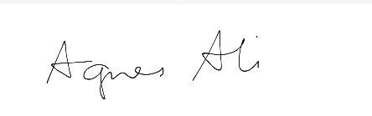
Agnes Ali
BSC (Hons) Optometry, MBABO, GOC-01-24746

Please Note:
The assessment performed, and the report above has been designed to enable a Behavioural/ Neuro-Developmental Optometrist to gain enough understanding of a person’s presenting or undiagnosed visual difficulties, to be in a position to recommend a tailored and specific course of therapeutic action. It is not an exhaustive assessment of every possible aspect of the person and their difficulties, neither has it been prepared for any purpose other than to provide a better understanding of the visual system to the person concerned and their family.

Further reading:
Reflexes Learning and Behaviour by Sally Goddard. Fern Ridge Press. Eugene. OR.

Attention, Balance and Co-ordination – the A,B,C of Learning Success. Wiley-Blackwell. Oxford

The Well Balance Child, Hawthorn Press. Stroud

Releasing Educational Potential Through Movement. 2005. Sally Blythe SA Child Care in Practice. 11/4:415-432

